

SITE-SPECIFIC
Emergency Procedures

Prepared By: Division of State Parks
In Conjunction With: The Division of State Parks Safety Committee

Created: March 2022

STATE OF NEVADA
DEPARTMENT OF CONSERVATION & NATURAL RESOURCES
Division of State Parks
Web: www.parks.nv.gov
Email: vanessalmason@parks.nv.gov
Phone: (775) 684-2797 Fax: (775) 684-2777

ACKNOWLEDGEMENTS

Administration
Bob Mergell – Administrator
Janice Keillor – Deputy Administrator
Jonathan Brunjes – Deputy Administrator

Training and Safety
Josh Rhein – L.E. and Training Specialist
Vanessa Mason – Safety Representative - Consultation

Contributors:
2021 Division of State Parks Safety Committee

Tahoe Region
Allen Woodridge – Tahoe Region Manager
Allen Wooldridge – Park Supervisor, III – Sand Harbor
Jimmie Popham – Park Maintenance Specialist – Sand Harbor

Eastern Region
Cody Tingey – Eastern Region Manager
John Wells – Park Maintenance Specialist – South Fork SRA
Vacant – Park Technician III – Wild Horse SRA

Western Region
Brad Larkin – Western Region Manager
Charlie Wells – Facility Manager
Ashlee Goeddel – Park Ranger III – Lahontan SRA
Don Frade – Park Maintenance Specialist – Walker River SRA
Rett Smith – Park Maintenance Specialist – Walker River SRA

Southern Region
Craig Robinson – Southern Region Manager
Robert M. Ryan – Park Ranger I – Big Bend of the Colorado SRA
Josh Yelle – Park Interpreter – Spring Mountain Ranch
Leo J. Tylkowski – Park Maintenance Specialist – Valley of Fire

Table of Contents
I. PURPOSE 4
II. AUTHORITIES 4
III. EMERGENCY PERSONNEL NAMES AND PHONE NUMBERS 4
IV. EVACUATION ROUTES 5
V. EMERGENCY PHONE NUMBERS 6
VI. PROCEDURES FOR EMERGENCY EVACUATION 7
V. PROCEDURES FOR MEDICAL EMERGENCY 8
VI. Procedures for reporting a fire or other emergency 9
VII. PROCEDURES FOR REPORTING AN EXTENDED POWER LOSS 10
VII. PROCEDURES FOR REPORTING A CHEMICAL SPILL 11
IX. PROCEDURES FOR BOMB THREAT 12
X. PROCEDURES FOR SEVERE WEATHER AND NATURAL DISASTERS 17
XI. Review of emergency action plan 18
XII. Reporting 19

I. PURPOSE
The purpose of the Division of State Parks Emergency Evacuation Plan is to:
- Ensure a written plan, kept in the workplace, is available to employees for review.
- Show employees how to safely exit the site facilities and handle the various components of an emergency situation.
- Comply with 29 CFR, OSHA 1910.38, Exit Routes and Emergency Planning.

II. AUTHORITIES
29 CFR, OSHA 1910.38.

III. EMERGENCY PERSONNEL NAMES AND PHONE NUMBERS
(Insert names and numbers)
DESIGNATED RESPONSIBLE OFFICIAL
Name: Phone: (________________)

EMERGENCY COORDINATOR:
Name: Phone: (______________)

AREA/FLOOR MONITORS (If applicable):
Area/Floor: Name: Phone: (_______________)
Area/Floor: Name: Phone: (_______________)

ASSISTANTS TO PHYSICALLY CHALLENGED (If applicable):
Name: Phone: (_______________)
Name: Phone: (________________)

Date ____/____/____

IV. EVACUATION ROUTES
EVACUATION ROUTES

• Evacuation route maps have been posted in each work area. In addition, the following information is marked on evacuation maps:

- Emergency exits
- Primary and secondary evacuation routes
- Locations of fire extinguishers
- Fire alarm pull stations' location
- Assembly points

• Site personnel should know at least two evacuation routes (insert a copy of the evacuation map here).

V. EMERGENCY PHONE NUMBERS
EMERGENCY PHONE NUMBERS
Insert appropriate phone numbers

FIRE DEPARTMENT: _______________________

AMBULANCE: _____________________________

POLICE: ___________________________________

FEDERAL PROTECTIVE SERVICE: ________________

ELECTRIC: _____________________

WATER: _______________________

GAS (if applicable): __________________________

TELEPHONE COMPANY: _______________________

REMAIN CALM
THINK CLEARLY
ACT DECISIVELY

VI. PROCEDURES FOR EMERGENCY EVACUATION
EMERGENCY REPORTING AND EVACUATION PROCEDURES

Types of emergencies to be reported by site personnel are (insert any additional site-specific potential emergencies if applicable):

• MEDICAL

• FIRE

• SEVERE WEATHER

• BOMB THREAT

• CHEMICAL SPILL

• STRUCTURE CLIMBING/DESCENDING

• EXTENDED POWER LOSS

• OTHER (specify)___________________________________
(e.g., terrorist attack/hostage taking)

V. PROCEDURES FOR MEDICAL EMERGENCY
MEDICAL EMERGENCY
- Call medical emergency phone number 9-1-1:

- Provide the following information:
- Nature of medical emergency,
- Location of the emergency (address, building, room number)
- Your name and phone number from which you are calling.
- Do not move the victim unless absolutely necessary.
- Call the following personnel trained in CPR and First Aid to provide the required assistance before the arrival of the professional medical help (insert names and phone numbers):
- Name: _______________________ Phone:_______________________
- Name: _______________________ Phone:_______________________
- If personnel trained in First Aid are not available, as a minimum, attempt to provide the following assistance:
  - Stop the bleeding with firm pressure on the wounds (note: avoid contact with blood or other bodily fluids).
  - Clear the air passages using the Heimlich Maneuver in case of choking.
  - In case of rendering assistance to personnel exposed to hazardous materials, consult the Safety Data Sheet (SDS) and wear the appropriate personal protective equipment. Attempt first aid ONLY if trained and qualified.

VI. Procedures for reporting a fire or other emergency
FIRE EMERGENCY
When a fire is discovered:
- Activate the nearest fire alarm (if installed)
- Notify the local Fire Department by calling _______________________________________.
If the fire alarm is not available, notify the site personnel about the fire emergency by the following means (check applicable):

- Voice Communication
- Phone Paging
- Radio
- Other (specify)

Fight the fire ONLY if:
- The Fire Department has been notified.
- The fire is small and is not spreading to other areas.
- Escaping the area is possible by backing up to the nearest exit.
- The fire extinguisher is in working condition, and personnel is trained to use it.
Upon being notified about the fire emergency, occupants must:
- Leave the building using the designated escape routes.
- Assemble in the designated area (specify location):
- Remain outside until the competent authority (Designated Official or designee) announces that it is safe to reenter.
Designated Official, Emergency Coordinator, or supervisors must:
- Disconnect utilities and equipment unless doing so jeopardizes their safety.
- Coordinate an orderly evacuation of personnel.
- Perform an accurate headcount of personnel reported to the designated area.
- Determine a rescue method to locate missing personnel.
- Provide the Fire Department personnel with the necessary information about the facility.
- Perform assessment and coordinate weather forecast office emergency closing procedures.
Area/Floor Monitors must:
- Ensure that all employees have evacuated the area/floor.
- Report any problems to the Emergency Coordinator at the assembly area.
- Assistants to Physically Challenged should:
- Assist all physically challenged employees in an emergency evacuation.

VII. PROCEDURES FOR REPORTING AN EXTENDED POWER LOSS
EXTENDED POWER LOSS

In the event of extended power loss to a facility, certain precautionary measures should be taken depending on the geographical location and environment of the facility:

- Unnecessary electrical equipment and appliances should be turned off if power restoration would surge, causing damage to electronics and affecting sensitive equipment.
- Facilities with freezing temperatures should turn off and drain the following lines in a long-term power loss.
- Fire sprinkler system
- Standpipes
- Potable water lines
- Toilets
- Add propylene-glycol to drains to prevent traps from freezing
- Equipment that contains fluids that may freeze due to long-term exposure to freezing temperatures should be moved to heated areas, drained of liquids, or provided with auxiliary heat sources.

Upon Restoration of heat and power:
- Electronic equipment should be brought up to ambient temperatures before energizing to prevent condensate from forming on circuitry.
- Fire and potable water piping should be checked for leaks from freeze damage after the heat has been restored to the facility and water turned back on.

VII. PROCEDURES FOR REPORTING A CHEMICAL SPILL
CHEMICAL SPILL

The following are the locations of (insert locations):

Spill Containment and Security Equipment _____________________________________

Personal Protective Equipment (PPE) _________________________________________

SDS___________________________________________________________________

When a Large Chemical Spill has occurred:
- Immediately notify the designated official and Emergency Coordinator.
- Contain the spill with available equipment (e.g., pads, booms, absorbent powder, etc.).
- Secure the area and alert other site personnel.
- Do not attempt to clean the spill unless trained to do so.
- Attend to injured personnel and call the medical emergency number, if required.
- Call a local spill cleanup company or the Fire Department (if an arrangement has been made) to perform a large chemical (e.g., mercury) spill cleanup (insert information).
  - Name of Spill Cleanup Company:________________________________________
  - Phone Number:_____________________________________________________
- Evacuate building as necessary

When a Small Chemical Spill has occurred:
- Notify the Emergency Coordinator and/or supervisor (select one).
  - If toxic fumes are present, secure the area (with caution tapes or cones) to prevent other personnel entering.
  - Deal with the spill following the instructions described in the SDS.
  - Small spills must be handled safely while wearing the proper PPE.
  - Review the general spill cleanup procedures.

IX. PROCEDURES FOR BOMB THREAT

If you receive a telephone bomb threat and are alone, ask the following questions and then call 9-1-1 to report the threat and notify the chain of command.

If you are working with another staff member, have them call 9-1-1 to report the bomb threat and notify the chain of command while you ask the following questions of the caller.

Questions to Ask the Caller
- Does the caller's number come up on the screen, or will the caller give you their phone number?
_________________________________________________________________________________
- What is your name?
_________________________________________________________________________________
- When will the bomb explode?
_________________________________________________________________________________
- Where is it?
_________________________________________________________________________________
- What does it look like?
_________________________________________________________________________________
- What kind of bomb is it?
_________________________________________________________________________________
- What will cause it to explode?
_________________________________________________________________________________
- Why was it placed at the park?
_________________________________________________________________________________
- Did you place the bomb? If not, who did?
_________________________________________________________________________________
- If the caller says they didn't place the bomb and won't say who did, then ask, "How do you know so much about the bomb"?
_________________________________________________________________________________
- Does the caller seem familiar with the park or buildings (by their description of the bomb location)?
_________________________________________________________________________________
Notes on the Caller
VOICE CHARACTERISTICS |  | SPEECH PATTERN |  | LANGUAGE
___ Loud  ___ High Pitch  ___ Raspy  ___ Intoxicated  ___ Old  ___ Young | ___ Soft  ___ Deep  ___ Pleasant  ____________  Other | ___ Fast  ___ Distinct  ___ Stutter  ___ Slurred | ___ Slow  ___ Distorted  ___ Nasal  ____________  Other | ___ Excellent  ___ Fair  ___ Foul | ___ Good  ___ Poor  __________  Other
ACCENT |  | MANNER |  | BACKGROUND NOISES
___ Local  ___ Foreign | ___ Not Local  ___ Region | ___ Calm  ___ Rational  ___ Coherent  ___ Deliberate  ___ Righteous | ___ Angry  ___ Irrational  ___ Incoherent  ___ Emotional  ___ Laughing | ___ Factory  ___ Machines  ___ Music  ___ Office  ___ Street  ___ Traffic | ___ Trains  ___ Animals  ___ Quiet  ___ Voices  ___ Airplanes  ___ Party  ___ Atmosphere

Indicators for Explosives

Suspicious Package/Mail
If you receive a suspicious package, letter, or object under any circumstances. Do not touch it, tamper with it, or move it. Call 9-1-1.

Suspicious Package Characteristics
- Origin — Postmark does not match the city of the return address, the sender's name is unusual or unknown, or no return address is given.
- Balance — The letter is lopsided or unusually thick; the letter or package seems heavy for its size.
- Contents — Stiffness or springiness of contents; protruding wires or components; oily outer wrappings or envelope; feels like it contains a powdery substance.
- Smell — Particularly almond or other suspicious odors.
- Writing — Handwriting indicates a foreign style not normally received; cut-and-paste letters or rub on block letters are used. Common words, titles, or names are misspelled.
Vehicle-borne improvised explosive devices (VBIEDs)
Indicators that should be reported to authorities:
- Rental/delivery/utility vehicle or other vehicle parked in an unusual location.
- A driver who operates a vehicle overly cautiously and tries to abandon the vehicle or acts nervously.
- A driver displays non-compliant behavior, such as insisting on parking close to a building or crowded area.
- Excessive vehicle weight or unusually uneven weight distribution (e.g., the vehicle appears overloaded).
- Smoke or strong chemical or fuel odors emanate from a vehicle.
- Small test explosions in rural wooded areas.
Preventative measures
- Approach illegally parked tanker trucks or other vehicles around key facilities with caution.
- Question drivers about their cargo, destination, and reason for travel.
- Instruct them to move immediately.
- Watch out for vehicles riding low on their springs; they could be transporting explosives.
Improvised Explosive Device (IED)
If you suspect an IED is on-site
- DO NOT APPROACH OR TOUCH THE DEVICE.
- DO NOT ACTIVATE CELL PHONES OR RADIOS WITHIN 300 FEET OF THE DEVICE.
- IMMEDIATELY EVACUATE THE AREA AND NOTIFY THE AUTHORITIES.
- Avoid radio traffic if possible.
- Check for any planned events, threats, or other intelligence relating to that location.
Arriving on Scene
- Slow down and scan the area.
- Look for objects or people that seem out of place and beware of secondary devices.
- Establish a staging area for responders (avoid grouping in one location) and an outer security perimeter.
- Begin to implement the Incident Command System with the Unified Command Structure.
- DO NOT ENTER THE HOT ZONE until additional bomb squad, hazmat, SWAT, or Joint Hazard Assessment Team personnel are on the scene.
- Assist in setting up hot, warm, and cold zones. The larger the device, the larger the hot zone (300 feet or more).
- Limit the number of responders entering the perimeter and zones.
- Establish an escape route to leave the scene quickly.
- Be aware of choke points and other critical areas for additional devices.
- Avoid using radios and cell phones in the hot zone.
- Before entry, conduct detailed scans of the area with binoculars, spotting scopes, or vehicle-mounted cameras.
- Use caution and report any items that arouse suspicion.
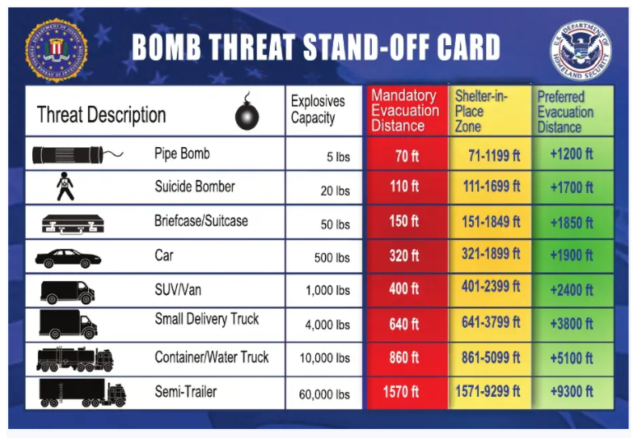
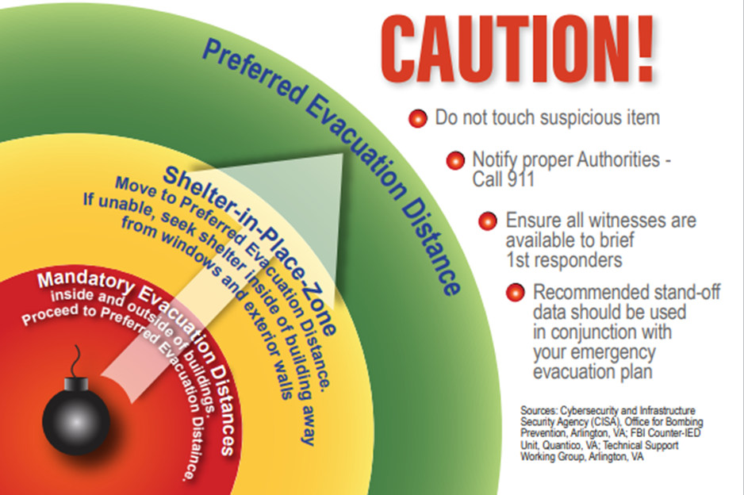
Notes:

X. PROCEDURES FOR SEVERE WEATHER AND NATURAL DISASTERS
SEVERE WEATHER AND NATURAL DISASTERS
Earthquake:
- Stay calm and await instructions from the Emergency Coordinator or the designated official.
- Keep away from overhead fixtures, windows, filing cabinets, and electrical power.
- Assist people with disabilities in finding a safe place.
- Evacuate as instructed by the Emergency Coordinator and/or the designated official.
Flood:
If indoors:
- Be ready to evacuate as directed by the Emergency Coordinator and/or the designated official.
- Follow the recommended primary or secondary evacuation routes.
If outdoors:
- Climb to high ground and stay there.
- Avoid walking or driving through flood water.
- If car stalls, abandon it immediately and climb to higher ground.
Blizzard:
If you are indoors:
- Stay calm and await instructions from the Emergency Coordinator or the designated official.
  - Stay indoors!
  - If there is no heat:
    - Close off unneeded rooms or areas.
    - Stuff towels or rags in cracks under doors.
    - Cover windows at night.
- Eat and drink. Food provides the body with energy and heat. Fluids prevent dehydration.
- Wear layers of loose-fitting, lightweight, warm clothing, if available.
If you are outdoors:
- Find a dry shelter. Cover all exposed parts of the body.
- If shelter is not available:
  - Prepare a lean-to, windbreak, or snow cave for protection from the wind.
  - Build a fire for heat and to attract attention. Place rocks around the fire to absorb and reflect heat.
  - Do not eat snow. It will lower your body temperature. Melt it first.
If you are stranded in a car or truck:
- Stay in the vehicle!
- Run the motor for about ten minutes each hour. Open the windows a little for fresh air to avoid carbon monoxide poisoning. Make sure the exhaust pipe is not blocked.
- Make yourself visible to rescuers.
    - Turn on the dome light at night when running the engine.
    - Tie a colored cloth to your antenna or door.
    - Raise the hood after the snow stops falling.
- Exercise to keep blood circulating and to keep warm.

XI. Review of emergency action plan
Insert the name or position of the person responsible must review the emergency action plan with each employee covered by the plan

XII. Reporting
WHISTLEBLOWER PROTECTION:
Nevada OSHA's Whistleblower Protection Program enforces the provisions of whistleblower statute NRS 618.445. Under NRS 618.445, it is against the law for a person to take an adverse action against an employee because the employee engaged in a protected activity such as filing a complaint with Nevada OSHA, cooperating with a Nevada OSHA investigation, voicing workplace safety and/or health concerns to management, or reporting a workplace injury. If a violation of NRS 618.445 is found, Nevada OSHA can seek remedies for the employee such as reinstatement, back pay, and work benefits.
An adverse action includes, but is not limited to:
- Termination or lay off
- Discipline
- Reduction of pay or hours
- Denial of a promotion
- Denial of work benefits
- Harassment
- Blacklisting
For more information, see the Whistleblower Investigations Manual

Appendix 1

Emergency Action Plan
State of Nevada
Division of State Parks

Under OSHA law, the Nevada Division of State Parks is responsible for providing employees a workplace free of known safety hazards. Therefore, our staff must understand who to call for help and the appropriate procedures to follow whenever they face an emergency.
The method we use for meeting that need is for the park supervisor or designee to review this document with staff upon initial hire, any time a change is made to the procedures or any time the employee desires clarification.
By signing this document, you affirm that this plan was reviewed with you and that you understand the procedures described therein.
If you do not fully understand the information or have questions, please contact your direct supervisor for assistance. Please sign this sheet once all of your questions have been satisfactorily answered.

___________________________________________ ____________________
Employee signature Date

