Safety Committee Meeting Agenda
Date | time 09/14/2021 9:00 AM| Location Zoom
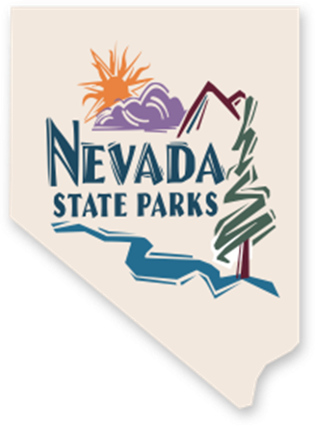 | Members:  John Wells – Park Maintenance Specialist - jwells@parks.nv.gov  Kody Kirby – Park Technician III - kkirby@parks.nv.gov  Josh Yelle – Park Interpreter - jyelle@parks.nv.gov  Robert Ryan – Park Ranger II - rmryan@parks.nv.gov  Leo Tylkowski – Park Maintenance Specialist - ltylkowski@parks.nv.gov  Ashlee Goeddel – Park Ranger II - agoeddel@parks.nv.gov  Don Frade – Park Maintenance Specialist - dfrade@parks.nv.gov  Charlie Wells – Facility Manager - charlie.wells@parks.nv.gov  Rett Smith - Park Maintenance Specialist at Walker River SRA - rsmith@parks.nv.gov  Allen Wooldridge – Park Supervisor, III - awooldridge@parks.nv.gov  Jimmie Popham – Park Maintenance Specialist - jpopham@parks.nv.gov  Josh Rhein – L.E. and Training Specialist - jrhein@parks.nv.gov  Vanessa Mason – Safety Representative – vanessalmason@parks.nv.gov  Cody Tingey – Eastern Region Manager - ctingey@parks.nv.gov  Craig Robinson - Southern Region Manager - crobinson@parks.nv.gov  Brad Larkin - Western Region Manager - blarkin@parks.nv.gov  *Region managers do not necessarily participate in each quarterly meeting but are invited to attend and want to be kept abreast of what the committee is doing in order to add input as necessary.
  Meeting called by | Vanessa Mason
  Type of meeting | Nevada Division of State Parks Safety Committee
  Facilitator | Vanessa Mason

Agenda Items
Topic | Time allotted
☐ | Call to Order | [Time]
☐ | Minutes | [Time]
☐ | Items of Business  - Round table introductions  - What has been happening since the last meeting?  - Park Inspections  - Recent Accidents  - Recent Park Hazards  - AED Update  - First Aid supply checklist  - OSHA 10 and 30 hour training  - Safety Training  - Toolbox Talks  - PowerPoint Presentations  - Safety Library  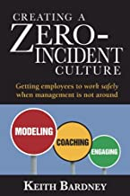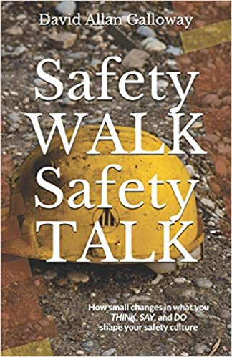  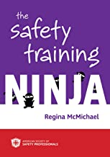  - Website  - Any volunteers for the Safety Page?  - Roundtable discussion | [Time]
☐ | Next Meeting Date  - December 14, 2021 | 9:00 a.m.
☐ | Meeting Dismissal | [Time]

