Nevada
Land and Water Conservation Fund (LWCF)
Grant Program

APPROXIMATELY $600,000 AVAILABLE
The deadline for LWCF grant applications is
March 23, 2018 12:00 pm.

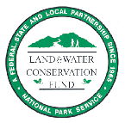
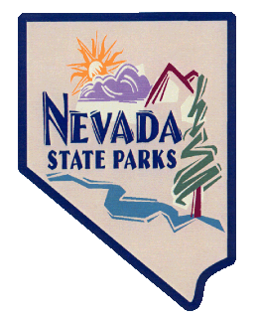
Program Administered
in Nevada By:

Nevada Division of State Parks
901 S. Stewart Street, Suite 5005
Carson City, NV 89701
Janice Keillor
(775 684 2787
jkeillor@parks.nv.gov
http://parks.nv.gov/grants/land-water-cons-fund/

How Much Is Available?

For Federal Fiscal Years 2018, approximately $600,000 is available to Nevada’s political subdivisions and Native American tribal governments.

Who is Eligible to Apply?

All political subdivisions within the state including counties, cities, towns, general improvement districts, and Native American tribal governments, which have legal authority to operate parks or provide recreation services, are potentially eligible for the 50:50 matching grants offered through the program. The local matches can consist of cash, in-kind labor, volunteer labor, and donated property, materials, or equipment.

What Types of Projects Are Eligible?

Financial assistance is available through the LWCF to provide most facilities necessary for the use and enjoyment of outdoor recreation areas. Both acquisition and development projects are eligible. Funding of development proposals may cover construction, renovation, site planning, demolition, site preparation, and architectural/ engineering services.

Examples of development projects include: sports & play fields, picnic facilities, trails, swimming facilities, boating facilities, fishing/hunting facilities, winter sports facilities, campgrounds, outdoor exhibits, spectator facilities, community gardens, major renovation or redevelopment of recreation facilities, provision of access to recreation facilities for persons with disabilities. The funds can also be utilized for recreation support facilities such as access roads, parking, walkways, restrooms, utilities, visitor or interpretive centers and pavilions.

How Are Projects Selected?

Applications are scored by an Ad Hoc Committee in accordance with established criteria which can be found in the grant manual on State Parks website.

How Do I Apply?

You may obtain a copy of the LWCF grant application on State Parks’ website: http://parks.nv.gov/about/grant-programs/land-and-water-conservation-fund.

The deadline for the 2018 LWCF grant application is March 23, 2018 12:00 pm. Applications submitted via email. Evaluation and selection of projects will take place in April with projects being awarded by June 1, 2018. The timely awarding of the grants is subject to the Federal Government spending bills and legislation.

Prospective applicants should contact Janice Keillor (775-684-2787 or jkeillor@parks.nv.gov) or Art Krupicz (775-684-2775 or rectrails@parks.nv.gov) with any questions regarding the program.

