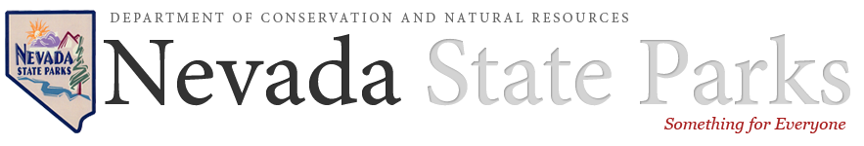

Sample Codicil

[date]

I, [name], a resident of the County of [county], State of [state], declare that this is the codicil to my last will and testament, which is dated [date original signed].

I add or change said last will in the following manner:

[List all specific changes or additions to the original will. Reference each section number of the will and the specific language you will be affecting. This is where you could include a bequest to support our mission. See our suggested bequest language that can assist you.]

Otherwise, I hereby confirm and republish my will dated [date original signed], in all respects other than those herein mentioned.

I subscribe my name to this codicil this [day, e.g. 1st] day of [month], [year], at [full address where signed], in the presence of [full name of first witness to codicil], [full name of second witness to codicil], and [full name of third witness to codicil], attesting witnesses, who subscribe their names here in my presence.

Maker:

ATTEST

On the date last above written, [name], known by us to be the person whose signature appears at the end of this codicil, declared to us, [full name of first witness to codicil], [full name of second witness to codicil], and [full name of third witness to codicil], the undersigned, that the foregoing instrument, consisting of [number of pages to codicil] page(s) was the codicil to the will dated [date original signed]; who then signed the codicil in our presence, and now in the presence of each other, we now sign our names as witnesses.

Witness1:

Address:

Witness2:

Address:

Witness3:

Address:

Disclaimer
Please have your will or codicil drafted by an attorney who is familiar with the estate laws of the state where you live. We are not engaged in legal or tax advisory service.

The purpose of this website is to provide general gift, estate, and financial planning information. Watch for tax revisions. State laws govern wills, trusts, and charitable gifts made in a contractual agreement. Advice from legal counsel should be sought when considering these types of gifts.

For all legal purposes, please refer to our organization as:
Nevada Division of State Parks, 901 South Stewart Street, Suite 5005, Carson City, NV 89701
Tax ID: 88-6000022

