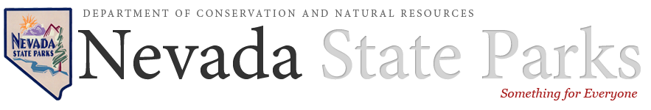

Sample Gift Language for your Will or Revocable Living Trust
A gift to Nevada State Parks in your will or revocable trust enables you to support our mission and make a difference in the lives of future generations. A bequest:
- is easy to arrange.
- will not alter your current lifestyle in any way.
- can be easily modified to address your changing needs.
When creating your will or trust, please refer to our organization as:
Nevada Division of State Parks, 901 South Stewart Street, Suite 5005, Carson City, NV 89701-5248
Tax ID: 88-6000022
Nevada allows an individual to compose his or her own will. However, a will is a very important legal document. Therefore, in the vast majority of cases, it is wise to employ the expertise of a qualified attorney. A will is one of the least expensive legal documents you would pay for, but a well-written will could save your heirs much more in dollars and hassle. A revocable trust should also be drafted by a qualified professional.
There are several different ways to include Nevada State Parks as a beneficiary of your will or trust. Here are some examples of suggested language to share with your attorney. Please feel free to adapt this language to fit your individual situation.

Residual Gift Language
A residual bequest comes to us after your estate expenses and specific bequests are paid:
I give and devise to Nevada Division of State Parks, 901 South Stewart Street, Suite 5005, Carson City, NV, all (or state a percentage) of the rest, residue, and remainder of my estate, both real and personal, to be used for its general support (or for the support of a specific fund or park).

Specific Gift Language
Naming Nevada Division of State Parks as a beneficiary of a specific amount or percentage of your estate is easy:
I give and devise to Nevada Division of State Parks, 901 South Stewart Street, Suite 5005, Carson City, NV, the sum of $___________ (%) to be used for its general support (or for the support of a specific fund or park).

Contingent Gift Language
Nevada Division of State Parks can be named as a contingent beneficiary in your will or personal trust if one or more of your specific bequests cannot be fulfilled:
If (insert name) is not living at the time of my demise, I give and devise to Nevada Division of State Parks, 901 South Stewart Street, Suite 5005, Carson City, NV, the sum of $ _______ (or all or a percentage of the residue of my estate) to be used for its general support (or for the support of a specific fund or park).

Retirement ACCOUNT Beneficiary Language
You may name Nevada Division of State Parks as a beneficiary of your IRA or other qualified retirement benefits. Donors should consult with their tax advisor regarding the tax benefits of such gifts.
Naming State Parks as the beneficiary of a qualified retirement account asset such as a 401(k), 403(b), IRA, Keogh or profit-sharing pension plan will accomplish a charitable goal while realizing significant tax savings. It can be costly to pass such assets on to heirs because of heavy tax consequences. By naming State Parks as a beneficiary of a retirement plan, the donor maintains complete control over the asset while living, but at the donor’s death the account passes to support the Foundation free of both estate and income taxes.
Making a charitable gift from your retirement plan is easy. Simply request a change-of-beneficiary form from your plan administrator. Then, enter Nevada Division of State Parks (Tax id # 88-6000022) on the form with the percent you would like us to receive. When you have finished, please return the form to your plan administrator and notify Nevada Division of State Parks. We can also assist you with the proper language for your beneficiary designation to State Parks.

