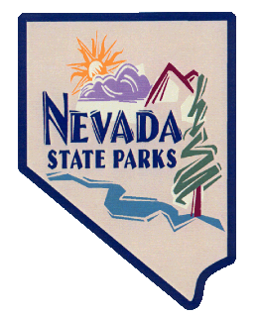
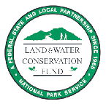

Nevada
Land and Water Conservation Fund (LWCF)
Grant Program

APPROXIMATELY $1,000,000 AVAILABLE
THE DEADLINE FOR LWCF GRANT APPLICATIONS IS
MARCH 27, 2023 11:59 PM.

Program Administered
in Nevada By:

Nevada Division of State Parks
Elyse Jolly, Program Manager
775 684 2775
emjolly@parks.nv.gov
WebGrants - Nevada State Parks (webgrantscloud.com)

How Much Is Available?

For Federal Fiscal Years 2023, approximately $1,000,000 is available to Nevada’s political subdivisions and Native American tribal governments.

Who is Eligible to Apply?

All political subdivisions within the state including counties, cities, towns, general improvement districts, and Native American tribal governments, which have legal authority to operate parks or provide recreation services, are potentially eligible for the 50:50 matching grants offered through the program. The local matches can consist of cash, in-kind labor, volunteer labor, and donated property, materials, or equipment.

What Types of Projects Are Eligible?

Financial assistance is available through the LWCF to provide most facilities necessary for the use and enjoyment of outdoor recreation areas. Both acquisition and development projects are eligible. Funding of development proposals may cover construction, renovation, site planning, demolition, site preparation, and architectural/ engineering services.

Examples of development projects include: sports & play fields, picnic facilities, trails, swimming facilities, boating facilities, fishing/hunting facilities, winter sports facilities, campgrounds, outdoor exhibits, spectator facilities, community gardens, major renovation or redevelopment of recreation facilities, provision of access to recreation facilities for persons with disabilities. The funds can also be utilized for recreation support facilities such as access roads, parking, walkways, restrooms, utilities, visitor or interpretive centers and pavilions.

How Are Projects Selected?

Applications are scored by an Ad Hoc Committee in accordance with established criteria which can be found in the grant manual on State Parks website.

How Do I Apply?

You may obtain a copy of the LWCF grant application on State Parks’ online grants portal: WebGrants - Nevada State Parks (webgrantscloud.com).

The deadline for the 2023 LWCF grant application is March 27, 2023, 11:59 pm. Applications must be submitted via the WebGrants portal. Applications submitted via mail or email will not be selected. Evaluation and selection of projects will take place in April with projects being awarded by Fall 2023. The timely awarding of the grants is subject to the Federal Government spending bills and legislation.

Prospective applicants should contact Elyse Jolly (775-684-2775, 775-434-4140 or emjolly@parks.nv.gov) or Janice Keillor (775-684-2787 or jkeillor@parks.nv.gov) with any questions regarding the program.

